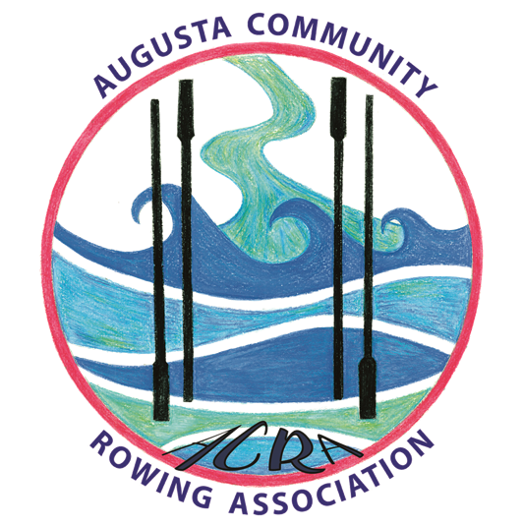
ACRA
Augusta Community Rowing Association Inc
PO Box 69
KARRIDALE 6288

augustarowers@gmail.com

2022 – 2023 SEASON (Season commencing 1 October 2022)
MEMBERSHIP APPLICATION (New Members)
MEMBERSHIP RENEWAL (Existing Members)
_______________________________________________

- Your membership of the Augusta Community Rowing Association Inc (ACRA) includes your membership of the Augusta Yacht Club Inc (AYC). Full membership will entitle you to use all AYC facilities and to full voting rights with AYC.
- Your ACRA membership fee includes your AYC membership fee (if you are not already an AYC member). ACRA rowing members will not be required to pay further membership fees to AYC, however, if you intend to participate regularly in AYC sailing activities you will be required to pay additional fees to AYC, such as the Yachting Australia Sailing Levy.
- If you are already a financial member of AYC for the 2022/23 year then you need only complete the attached ACRA form.
- If you are not already a financial member of AYC then please complete the attached ACRA form and the attached AYC form for AYC records.
- You will only need to have the ACRA form signed by a supporting member if you are not already an ACRA member (ie you are applying for a new ACRA membership). Forms can be signed by a supporting member after submission, so it is not necessary to have this completed beforehand.

Please complete the ACRA form and the AYC form (if necessary) and return both forms to ACRA at:
PO Box 69
KARRIDALE 6288
OR

augustarowers@gmail.com
OR
Hand deliver to any ACRA committee member

PAYMENT

Please pay all money by direct bank transfer or by cheque as below. Please include your surname on remittance or on bank deposit/transfer

By cheque to: By direct credit to:
Augusta Community Rowing Association Inc Bendigo Bank
PO Box 69 BSB: 633000
Karridale WA 6288 Account Number: 126162775

AUGUSTA COMMUNITY ROWING ASSOCIATION Inc

2022 – 2022 SEASON
MEMBERSHIP APPLICATION (New Members)
MEMBERSHIP RENEWAL (Existing Members)
________________________________________________

NAME: __________________________________________________________

ADDRESS: _______________________________________________________
________________________________________________________________
PHONE: _________________________________________________________
EMAIL: _________________________________________________________

Membership Category

Adult $110

Adult family (more than one paying member) $100 each

Adult already financial member of Augusta Yacht Club $30

Junior Family Membership (1 full adult member plus

1 junior under 15 associate member) $110

Social Member (non-voting member) $30

There are risks associated with water-based activities. All those taking part in any water-based activities conducted by the Augusta Community Rowing Association Inc do so at their own risk.
The Augusta Community Rowing Association Inc and its officials are not responsible for any damage or injury either ashore or on the water which might result from participating in activities conducted by the Augusta Community Rowing Association Inc.
The Augusta Community Rowing Association Inc thank you for observing a careful and sensible approach to your activities whilst ashore or on the water to ensure the safety of all.
I apply for membership of, or renewal of, my membership of ACRA and I accept the above conditions

Signed ………………………………………………………………………….………………… dated …………………………

Signed by supporting member
(not required for renewal )…………………………………………….…..dated………………………….

AUGUSTA YACHT CLUB: MEMBERSHIP FEES 2022-23
PO BOX 252 Augusta WA 6290
Treasurers Email: janetuptodate@gmail.com
MEMBER TYPE : SAILING Yes / No : ROWING: Yes / No
Member Name:
Address:
AGE : Birth Date:
Phone: Mobile: Email:
Voting Members:
Adult Single Membership: one person $ 80.00 or
Adult Family Membership $ 70.00 PP (more than one full family member)
Junior Membership: $25.00 per person OR
Junior Family Membership: $20.00 pp (eg 1 Adult 60.00 1 Jnr $20 = $80)
SAILORS - Yachting Australia
Yachting Australia Fees for sailors: $30.00
SAILORS discounted "upfront " sailing fee for Race days. $50.00
or $5.00 per person, per boat, to be paid on Race day.
Yacht Club Social Membership - Non Voting
Yacht Club "SOCIAL" sailing members: $30.00
BOAT STORAGE: ACTIVE members only $50.00 per boat, per year.
BOAT STORAGE: Non active members $250 per boat, per year.
TOTAL FEES DUE:
IMPORTANT NOTICE: There are risks associated with sailing and water based activities
The sailing Levy payable by AYC to Yachting Australia provides a small amount of personal Insurance cover against injuiry. However, it should
be noted that all those taking part in any sailing, water based, or other activities conducted by the Augusta Yacht Club do so at their own risk.
For this reason it is essential all vessels/skippers have Personal Libality Cover…...
I accept the above conditions:
Signature:
Neither the AYC or its Officials are responsible for any damage or injury, either ashore or on the water to persons or craft which might
result from participating in these activities or being on the premises of the Augusta Yacht Club.
AYC and its officials thank you for observing a careful and sensible approach to your activities whilst ashore or on the water. Your
vigilance is the best way to ensure the safety of yourself and others.
Please pay by cheque to Augusta Yacht Club
PO BOX 252
AUGUSTA WA 6290
or Direct Credit to Augusta Bendigo Bank: Augusta Yacht Club.
BSB 633 000 Account 126162775 Please include Surname on deposit slip
SIGNED FORMS TO BE RETURNED TO TREASURER WITH PAYMENT. Many thanks!

